**Expeiment No:- 06**

Q1. Generate 1000 data

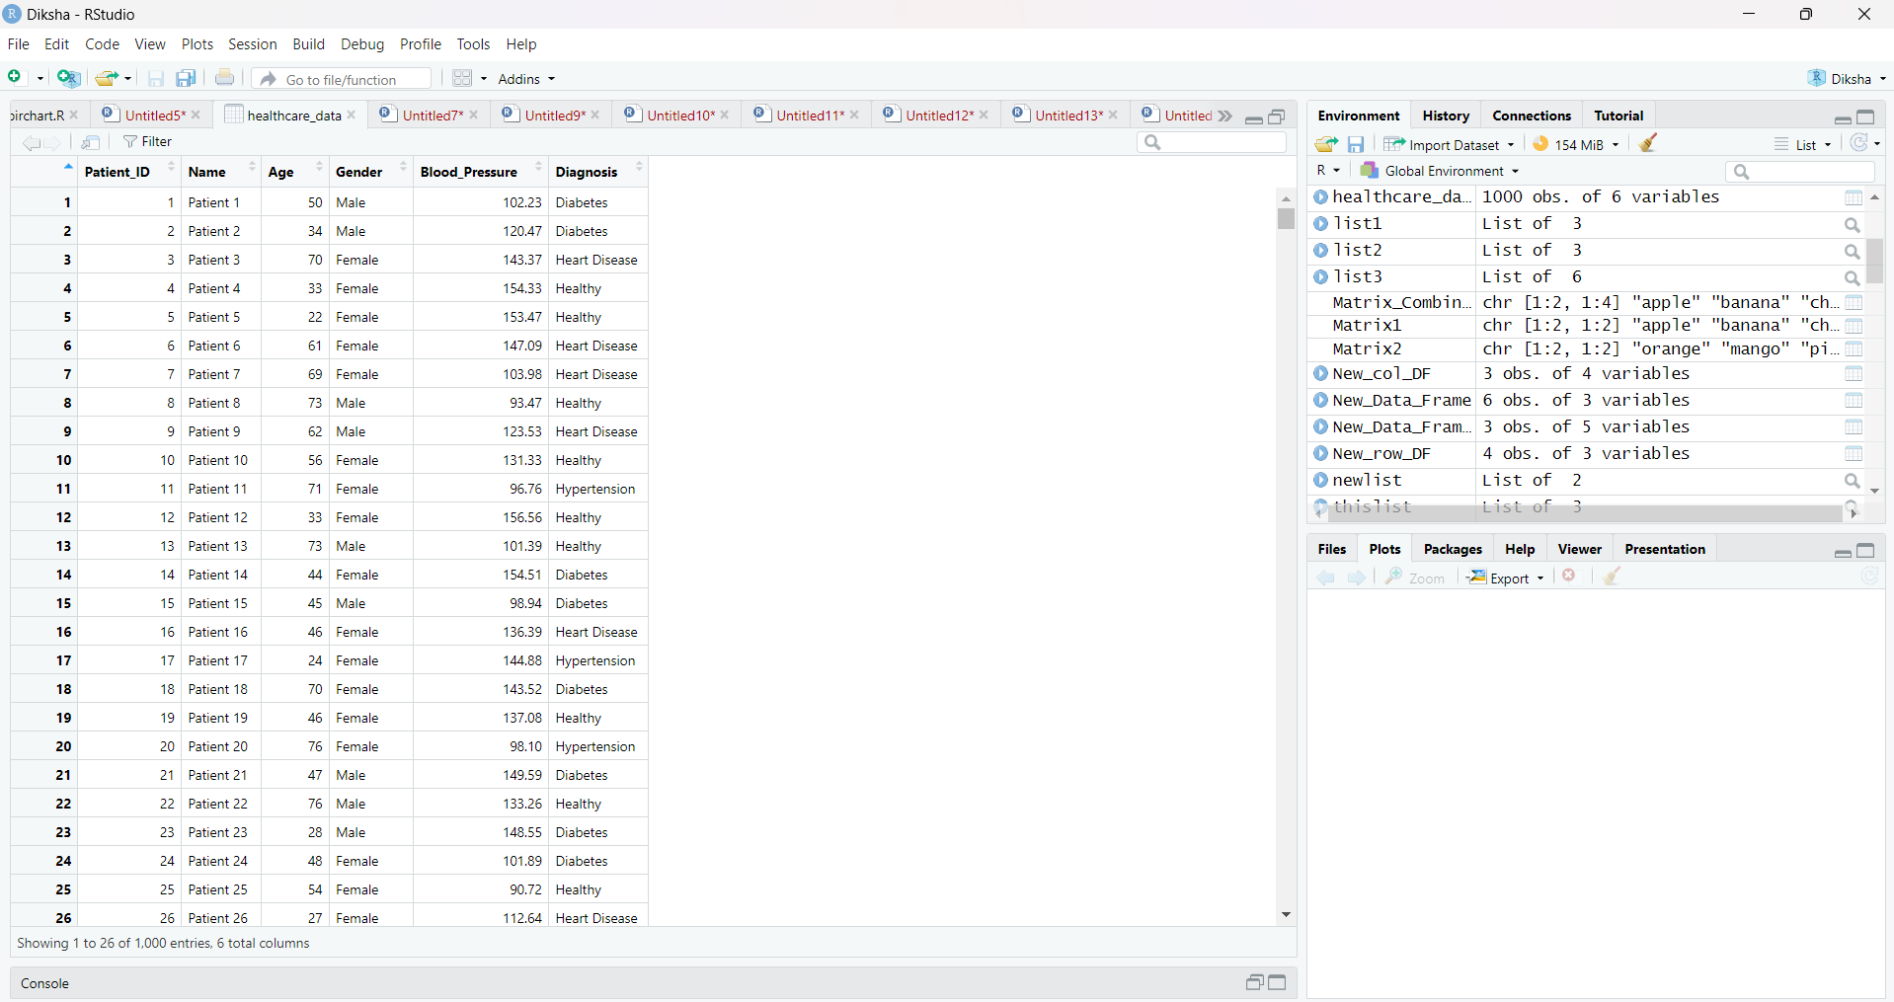

Q2. Histogram: Age Distribution

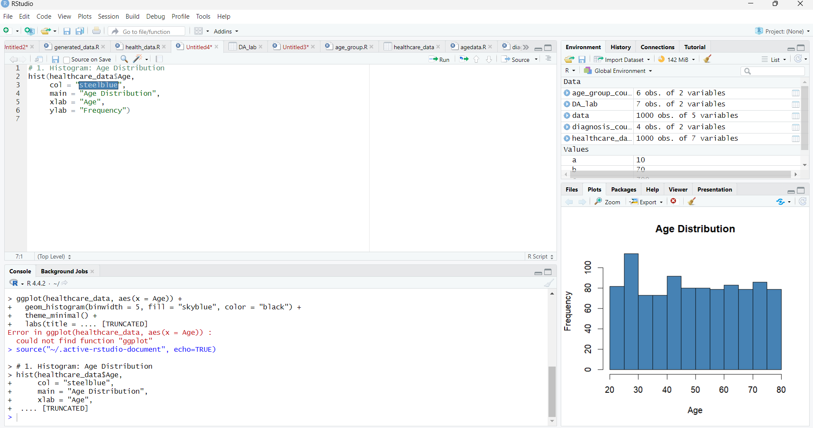

Q3. Boxplot: Blood Pressure by Diagnosis

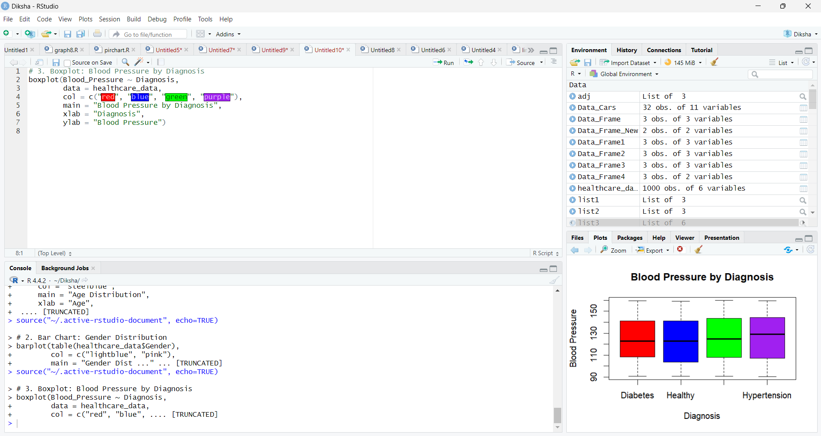

Q4. Pie Chart: Diagnosis Distribution

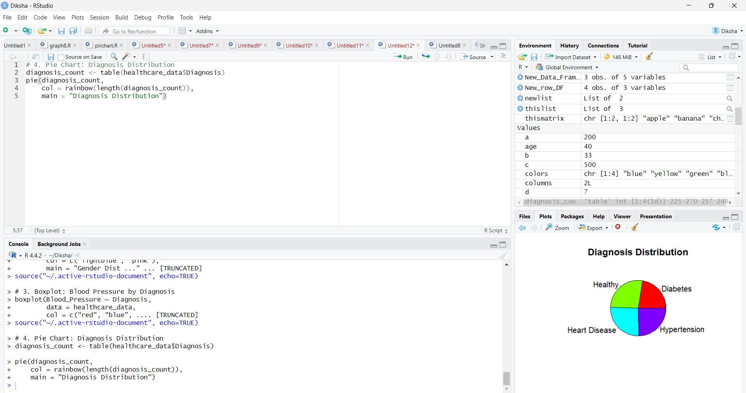

Q5. Scatter Plot: Age vs Blood Pressure

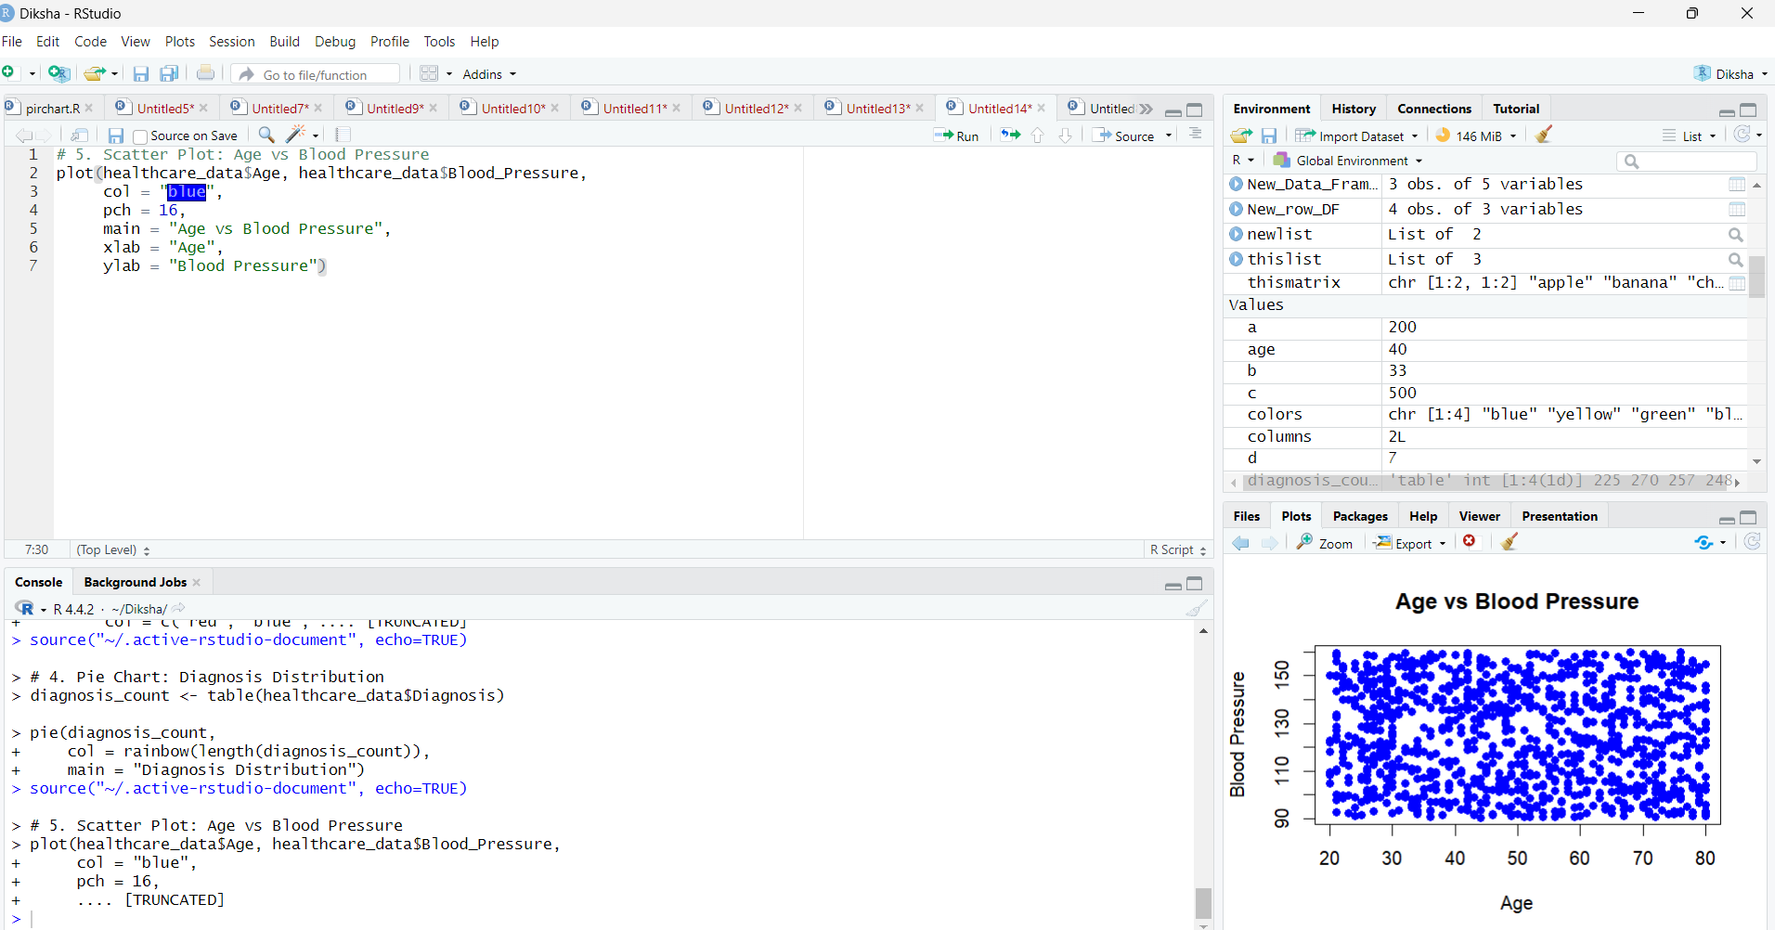

Q6. Density Plot: Blood Pressure Distribution

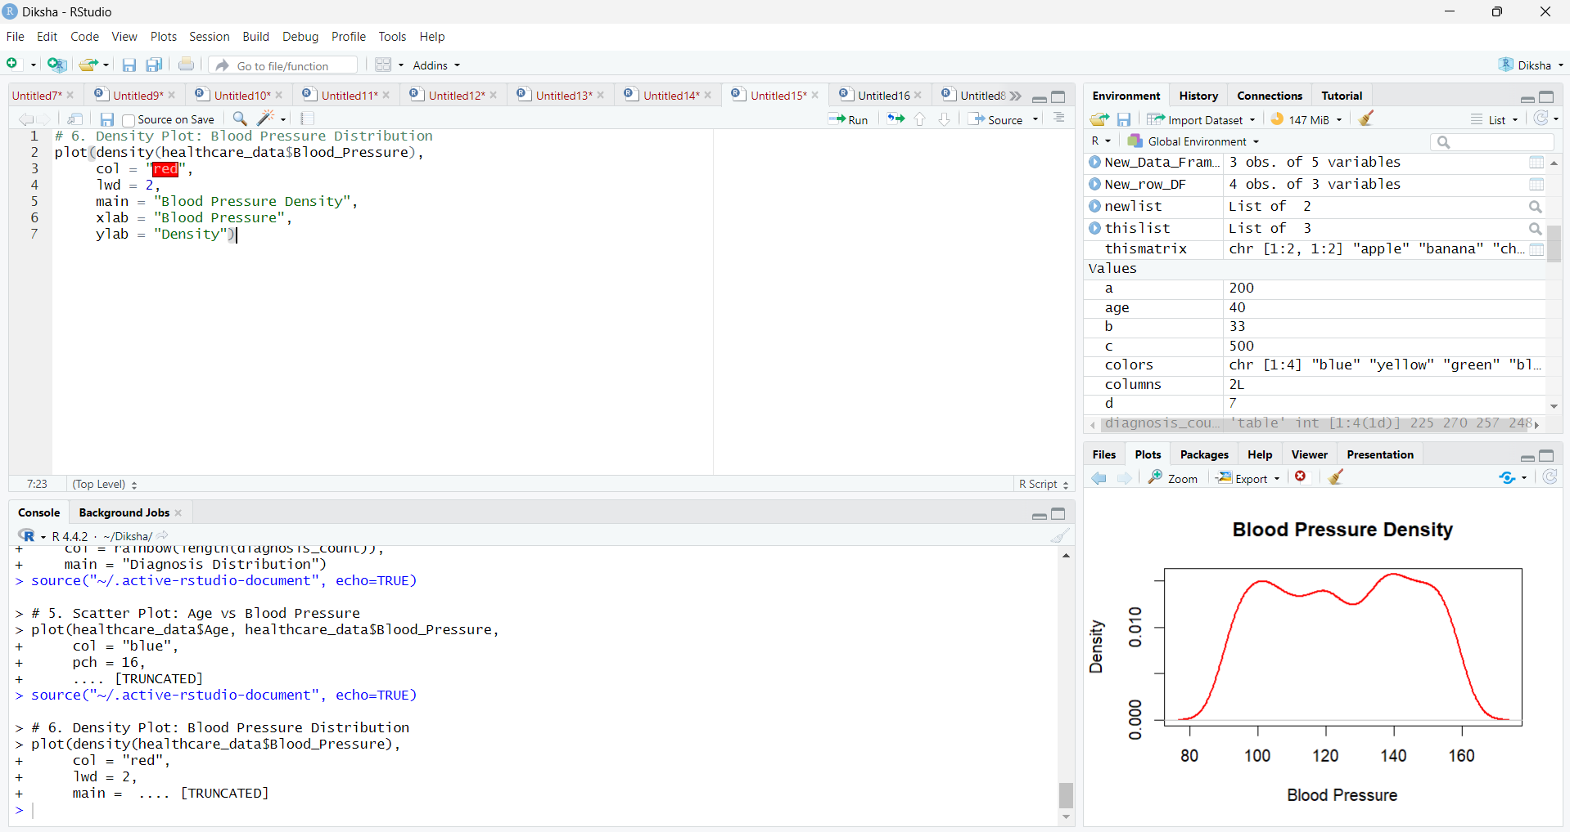

Q7. Stacked Bar Chart: Diagnosis by Gender

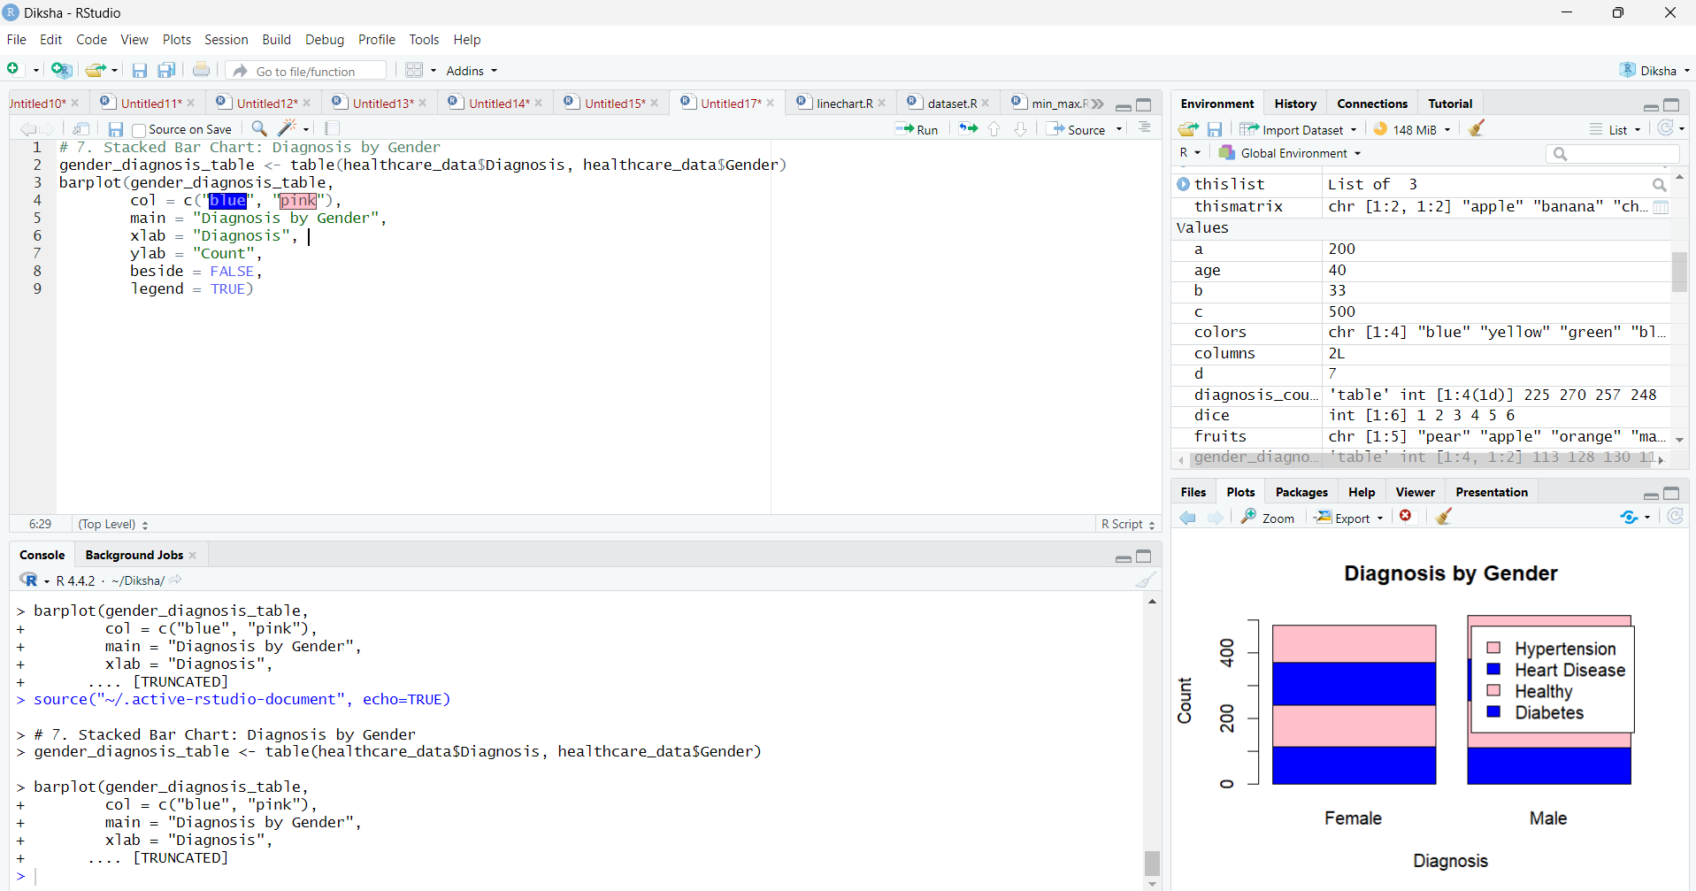

Q8. Line Chart: Trend of Blood Pressure with Age

